د.خوله عباس حسين
فرع الجراحة والتوليد /توليد
محاضرة نظري مرحلة خامسة

Ultrasonography
Ultrasonography was started to used In veterinary on the 1980 for diagnosis of pregnancy at the earliest gestational stage.
Ultrasonography can be defined as high frequency sound waves above the audible range. The frequency of these sound waves is described in cycles per second, or hertz (Hz). The picture that the ultrasound produce on the monitor was in different shades of white and black, Ultrasonic echoes that appear on the screen differ from black to white according to the degree of ultrasonic wave reflection Liquids, such as in the embryonic vesicle and ovarian follicles, was not reflect sound waves; they usually appear black and are described as non echoic, ultrasonic images for solid tissue, such as bones and the ruminant cervix, , show white due to the reflection of most sound waves and were described as echogenic or hyperechogenic. Images of soft tissues usually had varying gray shades. The urinary bladder is the landmark for ultrasonic examination of reproductive genital tract.
Ultrasonography examination trans-rectal in early pregnancy and Transabdominal in advance pregnancy, and has been used more frequencyfor pregnancy diagnosis .

Types of Ultrasonography systems
1 A-mode ultrasound (Amplitude-depth or echo-pulse)
In this system, the transducer containing one crystal emits ultrasound waves which penetrate the tissues under the skin and reflect when meet a high acoustic impedance interfaces (pregnant uterus or fluid-filled structures). The transducer receives the reflected echoes and converts them into peaks on oscilloscope with horizontal range representing the depth of the reflecting structure or into audible signal or to easy to hear signal.
A-mode ultrasound is quick and simple technique for diagnosis pregnancy, but it cannot predict the fetal number and the viability of fetus.
2 - Doppler ultrasound methods
The Doppler ultrasound Investigation of the uterine and umbilical arteries gives information on the perfusion of the uteroplacental and fetoplacental circulations,
Doppler devices used to detect the fetal heart beats and flow of blood in uterine and fetal vessels.
Pregnancy diagnosis with doppler ultrasonography can include movements as an indication of pregnancy such as fetal heart beat, fetal circulation and fetal movements, Fetal blood flow is the most diagnostic feature. Fetal pulse which is faster than maternal pulse or fetal movements are all positive criteria for pregnancy.

Real time ( B- mode Ultrasonography or B- scan)
B-mode or real-time ultrasound has become the preferred means of pregnancy diagnosis for small ruminants and other species. B-mode ultrasonography is an accurate, rapid and safe method for diagnosing pregnancy in small ruminants .

The Ultrasound system formed from two main part
1 Main Unit: The main unit formed from five main part
1- Timer 2- electrical pulse Generator 3- Receiver 4- digital scan converter 5- monitor
2- probe or transducer The probe is responsible for sending and receiving the sound signals while the screen converts the sound signal into an electrical signal, which is in the end viewed on the screen.
The probe classified two type according to the picture appeared . 1- Linear probe
The picture appeared (Rectangular image) ,the linear probe used to early pregnancy diagnosis, ovary examination ,and testis examination in male.
2. Sector probe
The picture appeared (Sector image) like Slice of pipe ,also the probe easy in using .
Also the probes classified two type according to the Ultrasonography frequency.
1- probe with low frequency (from 3 to 3.5)MHz
2- probe with high frequency (from 5 to7.5) MHz
Aliner Array tranduser (5MHz) rectagular image, good resolution, inter mediate depth (0-10cm) were used for pregnancy diagnosis and determination of fetal sexs. and linear array prostate tranducer(7.5MHz) reduced field depth (0-7cm) ,higer resolution was used to observe follical and corpus lutum, early pregnancy diagnosis,detrmination of fetal sex.and probe with best depth (0-20cm) lower resolution was used in advanced gestationand (3.5MHz)

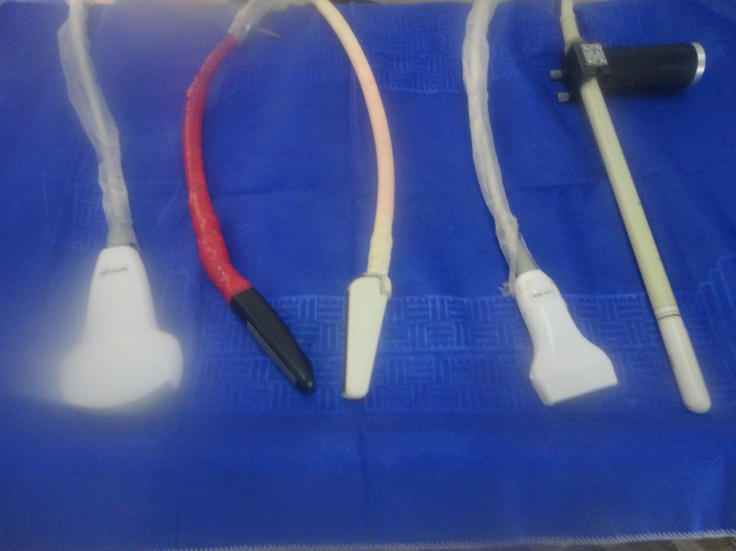
5 MHz
3.5 MHz
7.5 MHz

Figure show different probes equipped with the scanner system(3.5, 5, 7.5 MHz).

Reproductive Ultrasonography

  - 1) Ovarian structures Follicles are fluid-filled structures that appear black. The corpus luteum is a heterogeneous tissue, which appears medium gray.
  - 2) Uterus
Fetal viability can also be determined by Ultrasonography depended on the heart beats of fetus and movement .
Sex detection : Male - scrotal swelling, fetal prepuce beside umbilicus.
Female - lack of male structures and appearance of a vulva under the tail.

Use of B-mode Ultrasonography in diagnosis animals reproductive system
Usually, the ultrasonic findings of the pregnant and non pregnant uterus in animal depended The urinary bladder was the landmark for ultrasonic examination of both gravid and non gravid uterus in sheep and goats. the urinary bladder appears as anechoic structure seen trans-rectally as well as trans-abdominal on the floor of the pelvic cavity or caudal abdomen. when animals had been treated for super ovulation, the uterus appears with a fluid accumulation. The uterine wall had homogenous, non smooth .

